**CREATING AN E-COMMERCE PLATFORM ANALYSIS**

**Group-4**

**Presented by:**

**1. Kiarash Christiano Moshar**

**2. Sangamithra Murugesan**

Contents

Project Abstract: 3

Project Description: 4

Database Initial Study: 5

Objective: 5

Analysis and Requirement: 5

Problem and Constraint: 5

Scope: 6

Boundaries: 6

Database Design-Concept Design: 7

Conceptual Data Model: 7

Business Rules: As a customer 9

Business rules: As an enterprise 9

Business rules: Others 10

Database Design - Logical Design: 11

Logical ER-Diagram: 15

Database Design - Physical Design: 17

Data storage physical organization: 17

Security and Access control: 18

DBMS Selection: 19

Hardware and software used: 20

Implementation and Loading: 20

DBMS Installation: 20

Schema Creation: 21

Data Upload & Conversion 26

Testing & Evaluation: 31

Query Description: 33

Summary and conclusion: 39

# Project Abstract:

Our project is to build an ecommerce platform to act as an interactive portal for buyers and sellers. We plan to generate income based on the taking small commissions from each product sold. We have utilized datasets from a popular discount e-retailer called WISH to develop insights and ideas to make a successful product.

Given the current trend in ecommerce, customers prefer shopping from the comfort of their house and are increasingly willing to buy various products online.

In this business, there are two key users- merchants and customers. Everyday there are millions of these users who sign up as and the number of products that are available for online purchase continue to increase rapidly. This is great for the ecommerce business but at the same time, this blistering growth requires implementation of a strong backend system that can support large data volumes and complex operations in a timely manner.

In this project, we work to implement a successful ecommerce product. We will work to discover how to make a customer more excited towards a particular product and thereby increase sales. We also explore strategies to attract customers with product promotions and merchant management.

# Project Description:

The project uses the WISH enterprise database as a base to create an improvised shopping experience for the customers. The application will have millions of products listed for sales. There are a wide range of categories available for the customers to choose from. Most of the customers do not know what they are looking for. They log in most of the time to do window shopping. We take advantage of the behavior and implement many product promotional packages to the customers.

Like customers the merchants also play a major role in the business.

They have the opportunity to determine the price of the product, along with following some merchants. The merchants are rated by the customer with respect to shopping experience as they rate the products.

Here we implement a large variety of product promotional strategies like using add-boosters, discounts and coupons that will excite the customers to purchase the product. To which we perform simple analytical operations to verify the concepts. Mainly focusing on customer satisfaction and different strategies that could be implemented to increase the sales of products.

The project is designed in a way that the outcome of the project can be useful for any e-commerce platform who wish to have a similar business model.

# Database Initial Study:

## Objective:

Here we are building a data model that supports the ecommerce shopping experience from selecting the product via the application until the product reaches the customer. To design different strategies to improve the overall business of an e-commerce platform with respect to the products and the merchant side.

With the help of data analysis, we aim to obtain the following objective:

* Identifying the products that lack product visibility.
* Merchants that miss fulfillment before the required date.
* Performing analysis to check if add boosters help in sales of the product.
* Analyzing and improving the shipping pattern of the merchants

## Analysis and Requirement:

The concept of online shopping has been a trend for the past few years. Everybody loves to do shopping at their own comfort rather than walking into a physical store. This said the number of online stores have also increased. People have come to a position where they will be able to compare the price between online stores before purchasing a product.

In order to proceed with the project, we need a real time database with strong referential integrity to first understand where the business is losing its place in the market. Then we perform different analytical operations to come up with solutions that are implemented on a large scale.

## Problem and Constraint:

In this project we are limiting our scope up to the product being shipped to the customer. And we will not discuss how the payment should be processed. Or about the refund procedures of the e-commerce application.

Since we are trying to innovate the e-commerce business, there is not much data available for our project purpose, which results in data manipulation. Hence leaving us to predict the success of the implementation.

## Scope:

The scope of the project is to design a real-time data model that will be useful for any e-commerce application in terms of optimizing the operation of the organization. We also implement a few promotional strategies which help in by finding the area of improvements to increase the number of buyers from their platform.

## Boundaries:

The focus falls on the purchasing pattern. This process majorly involves the customer along with their respective merchants. And the associated activity including the order placing and the shipping parts.

# Database Design-Concept Design:

## Conceptual Data Model:

This is the preliminary database design model. Based on the real time application of the ecommerce website, this will be simplified in the further stages.

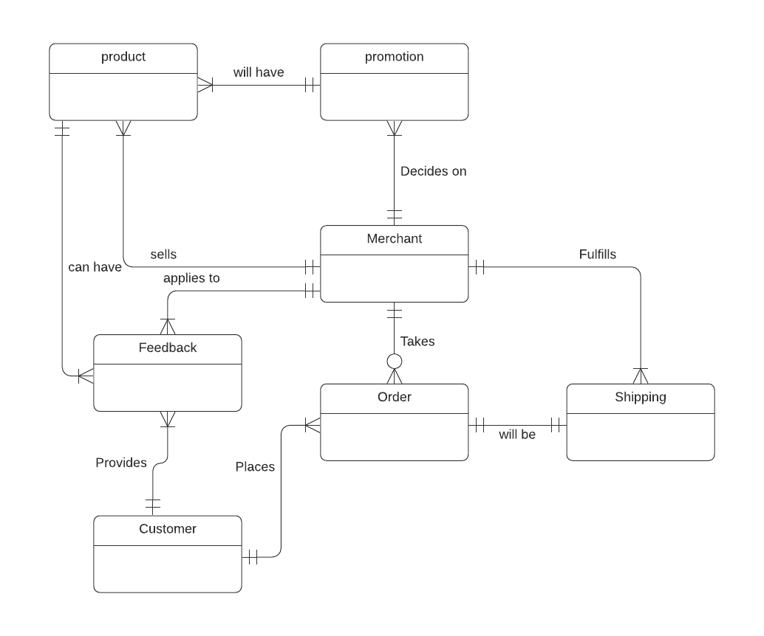

The possible Entities are:

* Product
* Promotion
* Merchant
* Feedback
* Customer
* Order
* Shipping

The possible Attributes are:

|  |  |
| --- | --- |
| Product_ID | For each individual product available in the web application, there is a separate Product_id |
| Product_Title | Provides the title of the product |
| Product_Information | Describes about the product-size and colour |
| Discounted_Price | The price posted after discount |
| Retail_price | The price of the product in an actual retail store |
| Custromer_ID | Each new customer who signs in will be assigned a customer_ID |
| Customer_information | Basic information about the customer including name, address, phone number, creating userid and password. |
| Rating_ID | Everytime a customer provides rating it will be associated to one product |
| Rating | The rating a customer provides to a product |
| Badges | A product can be awarded with a badge of appreciation by the enterprise. This will be displayed next to the product information, viewable to the customer. |
| Merchant_ID | Every merchant who signs up will be assigned a Merchant_ID |
| Merchant_Information | The merchant needs to provide their business information to create an account |
| Order_ID | Each time an order is placed an order ID is generated |

|  |  |  |  |
| --- | --- | --- | --- |
| **Entity** | **Relationship** | **Connectivity** | **Entity** |
| Product | M:1 | Will have | Promotion |
| Merchant | 1:M | Decides on | Promotion |
| Product | 1:M | Can have | Feedback |
| Merchant | 1:M | Sells | Product |
| Feedback | M:1 | Applies to | Merchant |
| Merchant | 1:M | Takes | Order |
| Order | M:N | Will be | Shipping |
| Customer | 1:M | Provides | Feedback |
| Customer | 1:M | Places | Order |
| Merchant | 1:M | Fulfills | Shipping |

## Business Rules: As a customer

* The customer first needs to create an account.
* They need to fill in mandatory fields like name, address, phone number, address and location.
* After successful login there will be millions of products available for the customer to browse.
* The customer will have access to the product review that was provided by the other customers who purchased the same product.
* The order can be placed once they decide on the product.
* The customer can rate the product and merchant

## Business rules: As an enterprise

* Merchants need to create an account initially.
* The need to provide their business information.
* Every merchant will be subjected to approval by the Wish team.
* Merchants are allowed to display as many numbers as possible of products they want on the platform.
* Merchants have the benefit of selecting the price of the products as long as they meet the policy guidelines.
* They have the option to promote their product using ad boosters.
* Qualified Products are given appreciation by giving them a small badge next to the product displayed.
* Each product can have a minimum of 0 to maximum of 3 badges.

## Business rules: Others

* Every time the customer places an order, they are consolidated and sent to their respective merchants.
* The merchants have to initiate the fulfilment process within 3 days, or they will be subjected to penalty.
* The shipping ID will be generated for each order that is placed.

# Database Design - Logical Design:

Before performing the logical design The normalizations process is required for our project to get clear understanding of the entities and attributes.

**1NF normalization:**

Schema at 1st Normal form:

Application(**Badge_ID,Customer_ID,Shipping_ID,Order_ID,Merchant_ID,Rating_ID,Product_ID**,Prod_title,Prod_description,Discounted_Price,Retail_price,Rating,Merchant_name,Merchant_name,Merchant_info,Merchant_ratinginfo,Order_date,Filfilment_date,Add_BoosterFlag,Shipping_tier,Cust_Name,Cust_Info,Badge_name,Badge_type,Badge_awardedon)

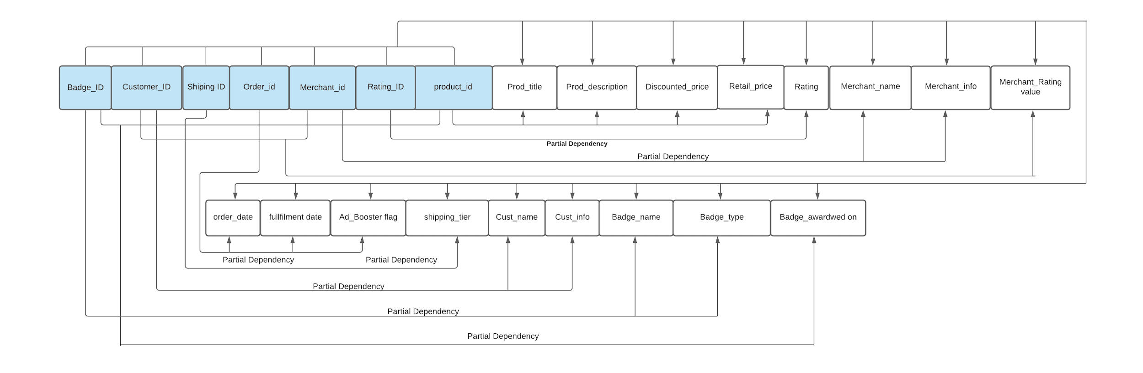

**2NF**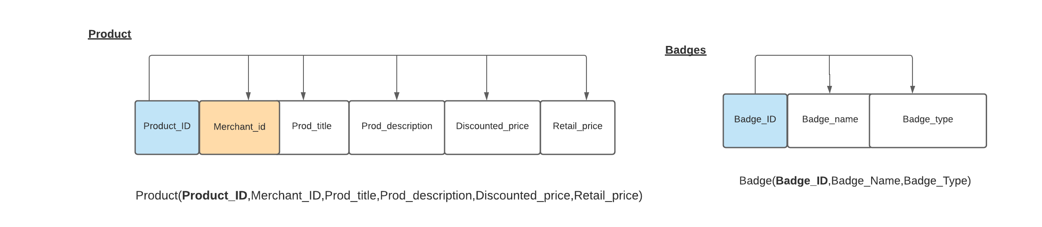

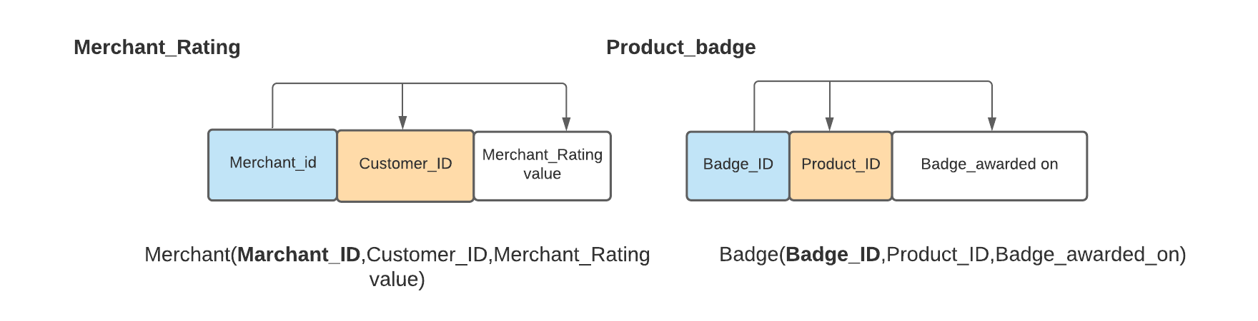

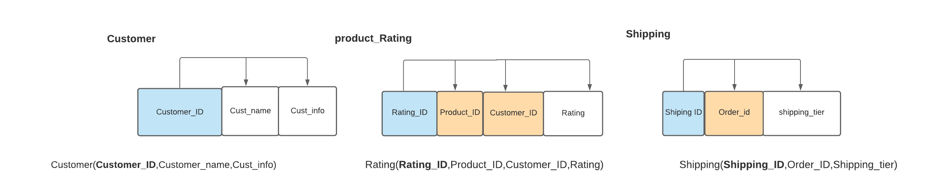

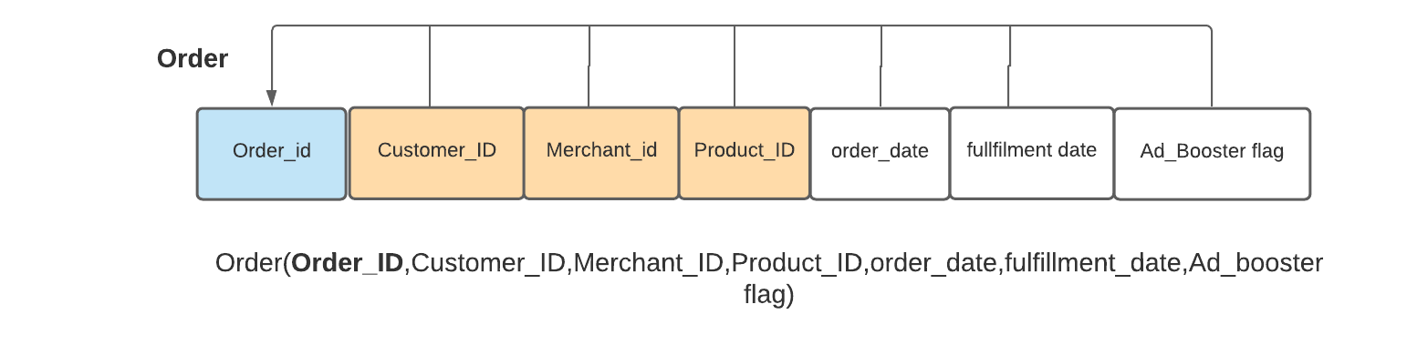

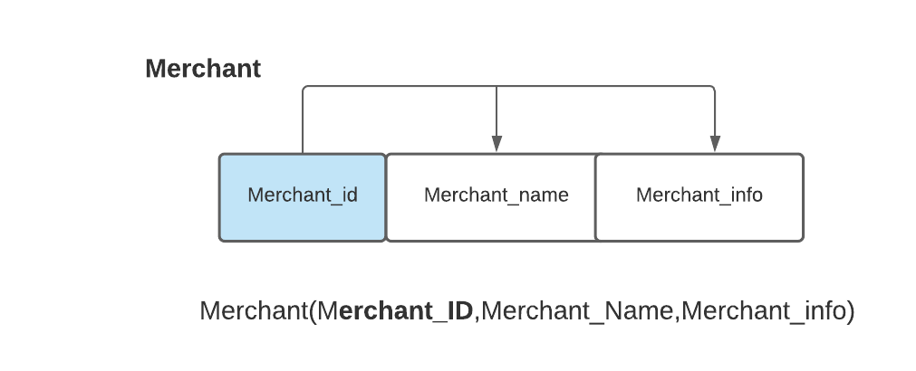

**3NF**

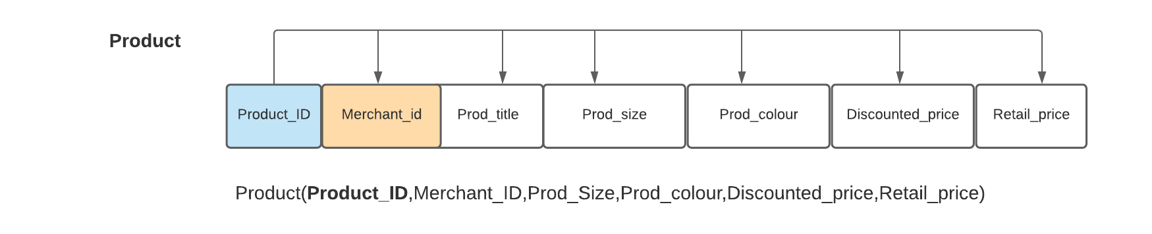

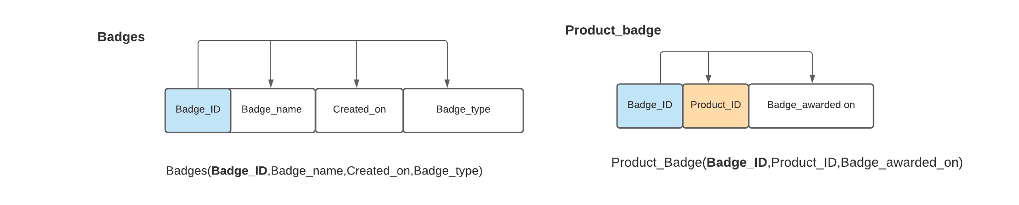

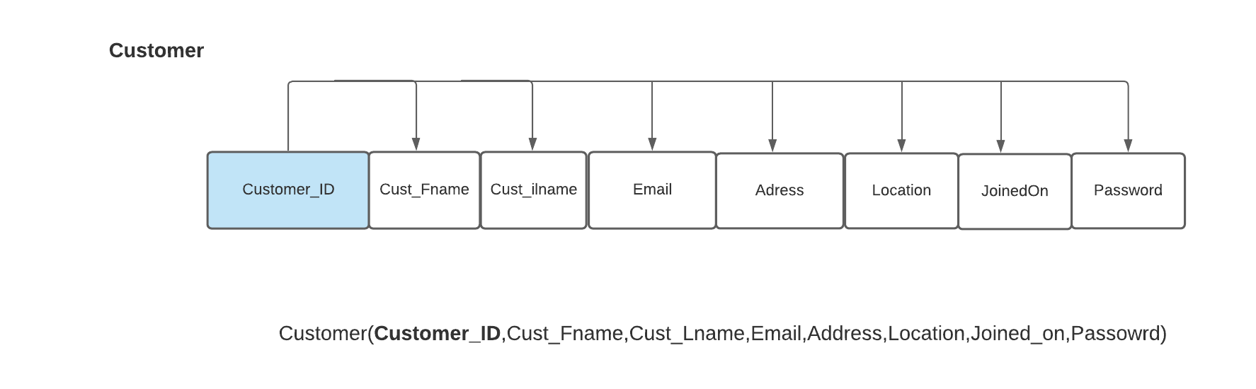

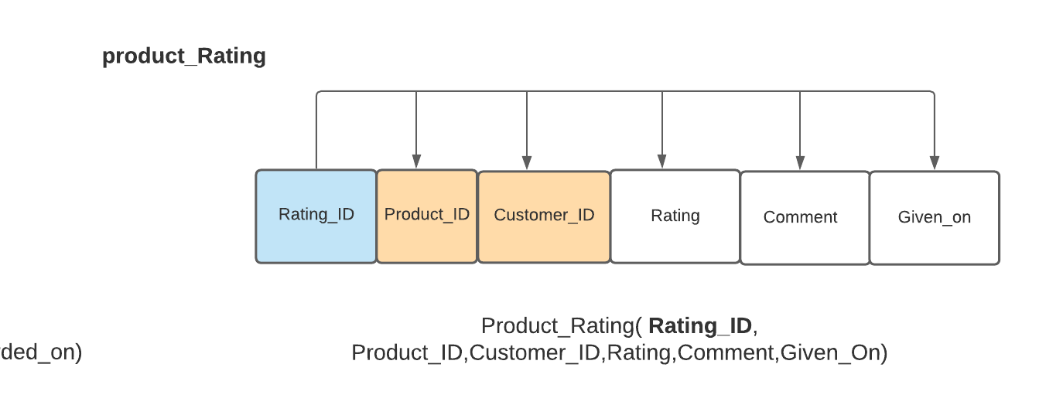

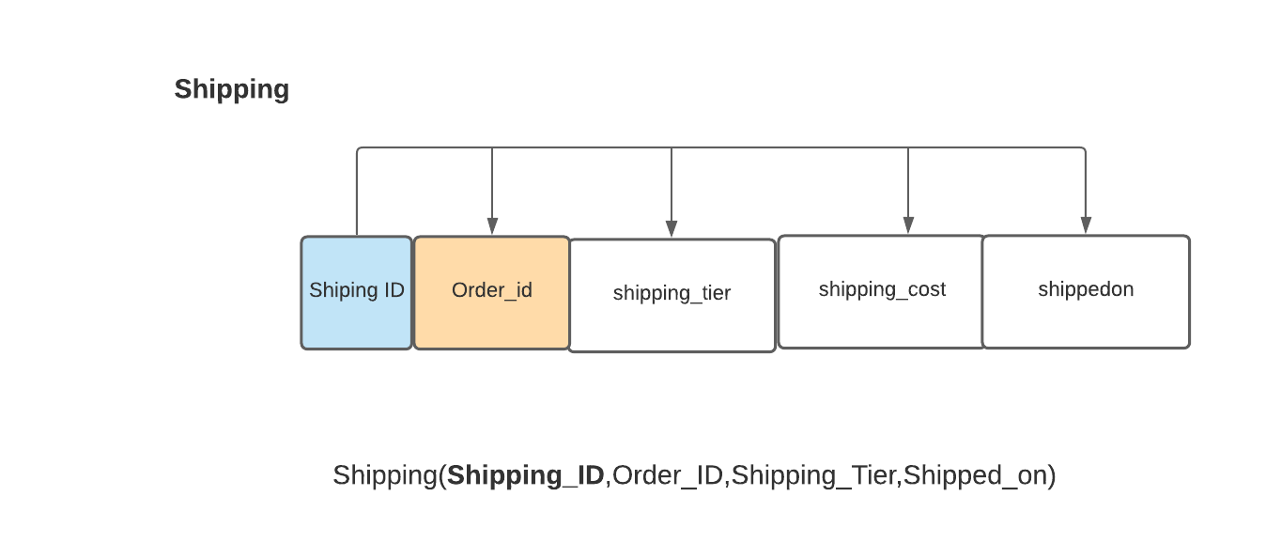

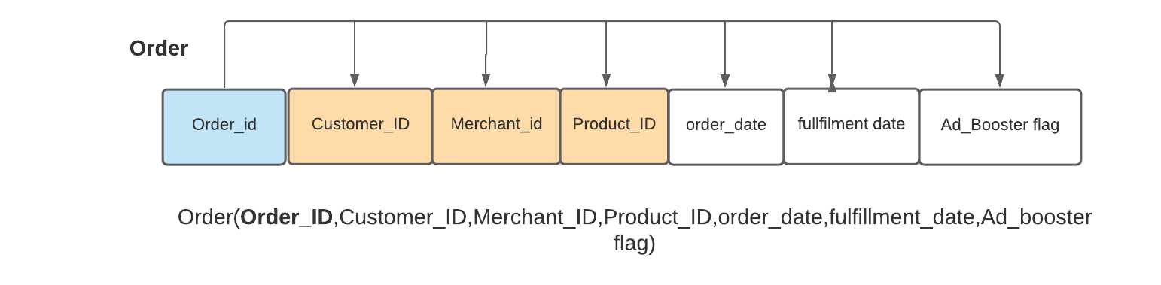

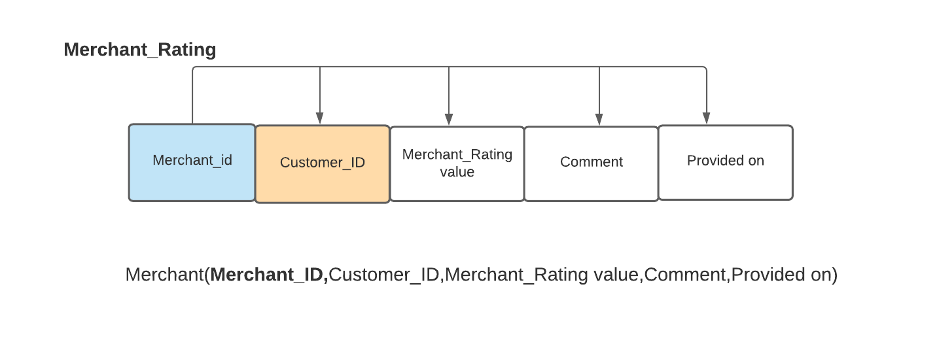

# Logical ER-Diagram:

**The following is the logical relationship between the tables:**

* Each customer can place multiple orders.
* A customer can provide zero or multiple ratings.
* Each product can have zero to 3 badges.
* Each order is associated with one product.
* A merchant can sell many products.
* Each product rating is associated with one product.
* Each order is subjected to one shipping ID.
* A merchant can take multiple orders.
* A merchant has multiple ratings.
* Each product is associated with one merchant.
* Products can have multiple product ratings.

**Tables and their attribute:**

|  |  |
| --- | --- |
| Product | Product_ID,Prod_Title,Prod_Size,Prod_Colour,Discounted_Price,  Retail_Price,Merchant_id |
| Customer | Customer_ID,Customer_fname,Customer_Lname,Email,Address,  Joinedon,Password |
| Merchant | Merchant_ID,Company_name,Merchant_email,StartedOn,Password |
| Orders | Order_ID,Order_date,Fulfillment_date,Selling_Price,Customer_ID,  Merchant_ID,Product_ID,Ad_Boosterflag |
| Shipping | Shipping_ID,Shipping_tier,Shipping_cost,Order_ID,Shipped_on |
| Product_Ratings | Rating_ID,Rating,Comment,Given_on,Customer_ID,Product_ID |
| Product_Badge | Badge_ID,Product_ID,Awarded_on |
| Badges | Badge_ID,Badge_Name,Badge_type,Created_on |
| Merchant_Rating | Merchant_ID,Customer_ID,Rating_value,Comment,Provided_on |

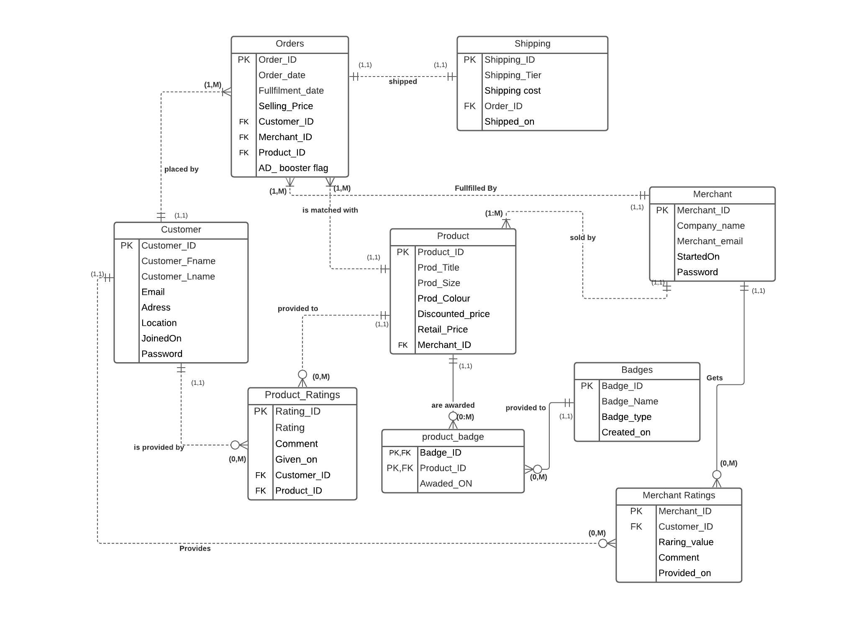

# Database Design - Physical Design:

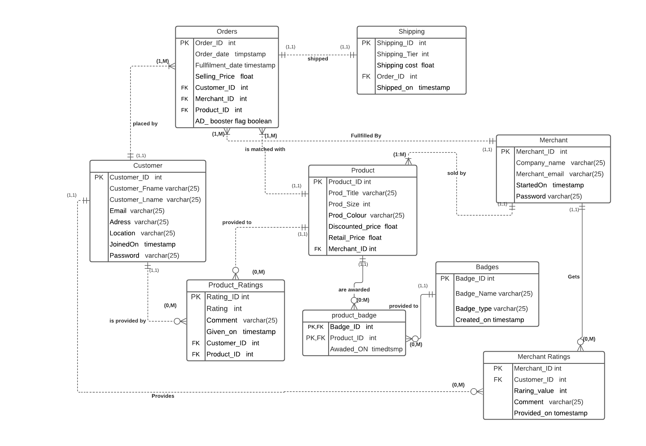

## Data storage physical organization:

For our project purpose we use SJSU Cloud that hosts Windows Server 2016 to store the sample WISH e-commerce data. But in real time for a successful ecommerce web application more than 150 billion new records are added per day. The organization will need a separate set of data warehouses to manage this kind of complex data that gets dumped into the system every day.

For our project, we keep our data files in Drive D. It is highly recommended that the data files, log files and Backup files are stored in different drives. Specially the Backup files are better to be in different Server.

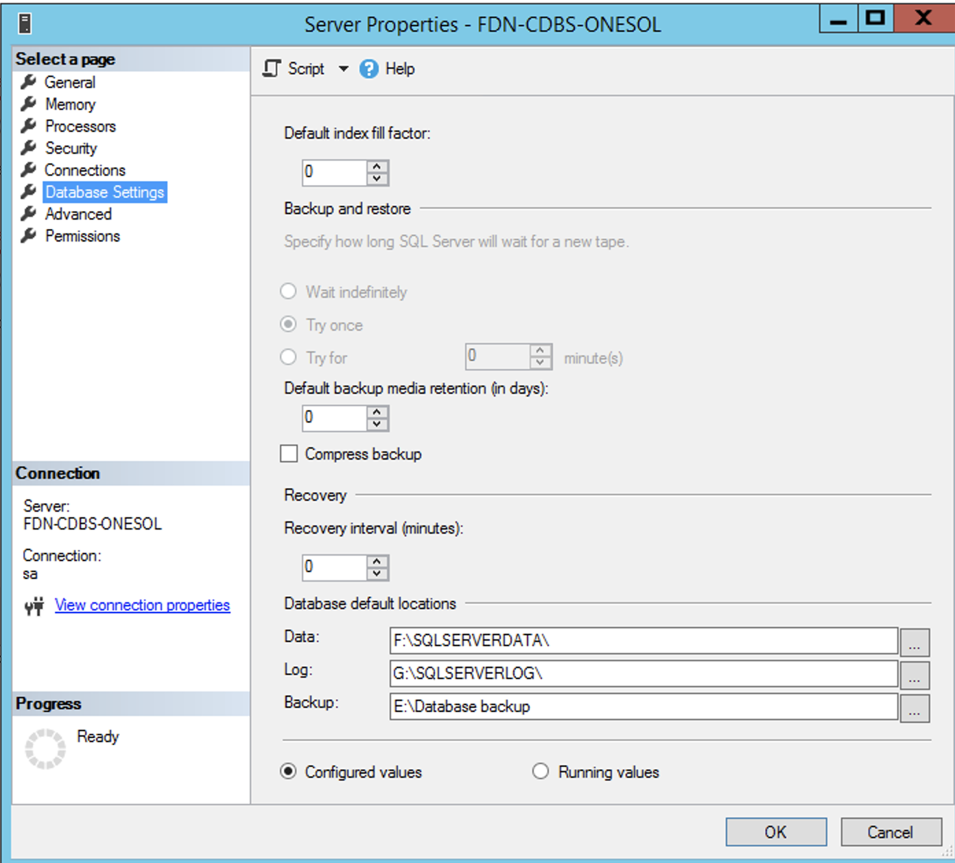

## Security and Access control:

Every ecommerce website has its own strong security systems. As it is important to have one. as the e-commerce business naturally stores all the customer’s information including the payment details.

With regard to the project:

* We created a simple UI Implementation, providing us an opportunity to do further studies and analysis. The database security logins are protected with Hash512 Password encryption and also the system is accessible through SJSU VPN.
* MSSQL Server can be accessed with either Windows authentication or SQL Server Authentication.
* SJSU VPN can be downloaded from the following link : <https://www.sjsu.edu/it/services/network/vpn/index.php>
* After Installation and connecting to VPN as instructed in above link, You can navigate to the link below:

<http://10.16.4.11:8090/scriptcase/app/security3_kiarash_amir/app_Login/app_Login.php>

## DBMS Selection:

DBMS Analysis:

Based on our project we need real time e-commerce operational data that involves the product, customer, merchants and more.

We require a good referential integrity that needs to be maintained throughout the project. And the RDBMS structure must be maintained throughout as everyday new amounts of data will be added, updated and deleted.

DBMS Selection:

In order to maintain the data integrity and data consistency, we use a relational DBMS system. The RDBMS helps us to maintain referential integrity throughout the project, as most of the table values heavily depend on one another.

## Hardware and software used:

Hardware:

We are using SJSU Remote Windows Server 2016 which the server is located in Las Vegas

Software:

* MSSQL Server 2016,
* PHP 7,
* Cisco AnyConnect VPN,
* Microsoft Remote Desktop,
* Scriptcase 9

# Implementation and Loading:

## DBMS Installation:

As we need RDBMS, we chose MSSQL Server 2016 for this project. SQL Server provides high scalability as it can be used for small projects as well as large applications. It helps in taking care of millions of transactions per day. It gives better performance and high speed while retrieving the data for the application.

Our Database name is SJSU_Project_data225 which we can create with Create database SQL Command.

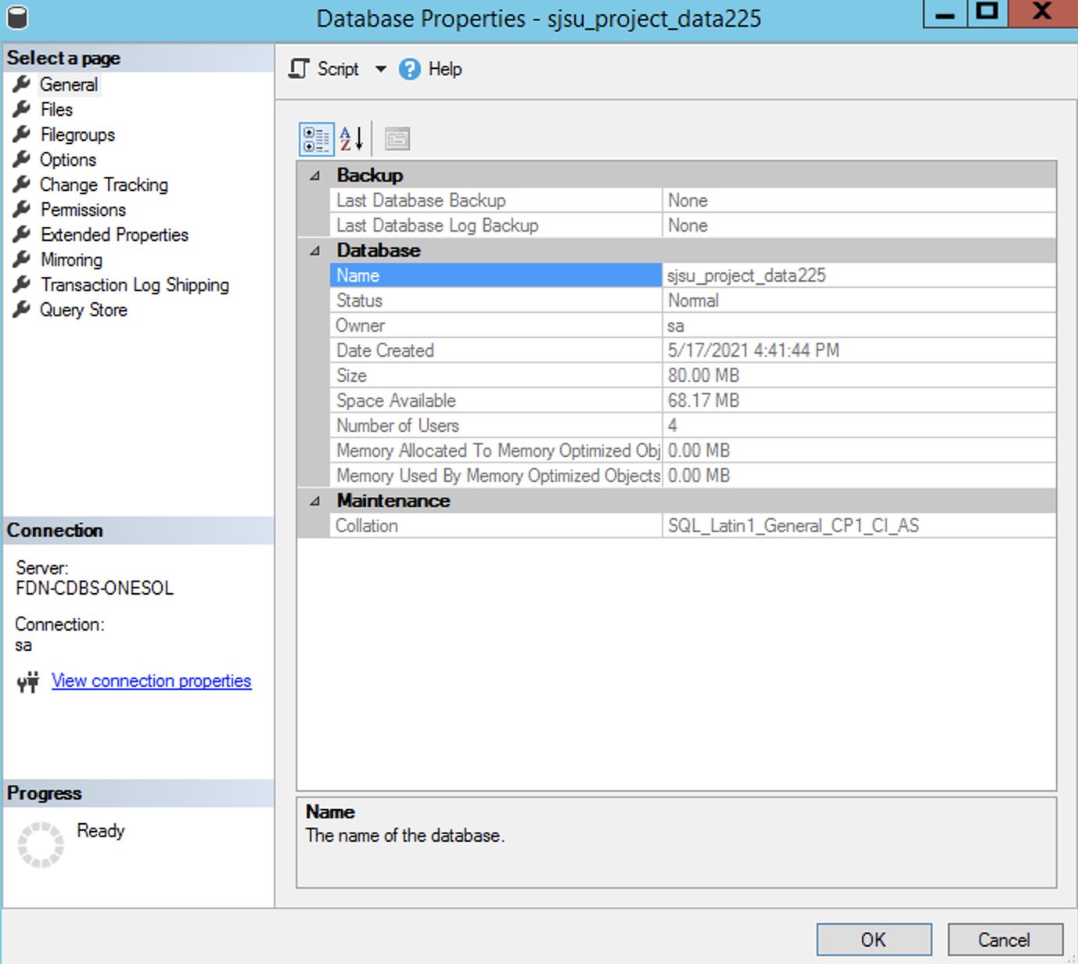

For the DBMS Installation:

MSSQL Server 2016 is installed on the server. we follow below tutorial:

<https://thycotic.force.com/support/s/article/Adv-Install-SQL-2016>

## Schema Creation:

1. Customer table

CREATE TABLE customer(

customer_id int PRIMARY KEY,

firstname varchar(255) NOT NULL,

lastname varchar(255) NOT NULL,

email varchar(255) NOT NULL,

contact_no varchar(15) NOT NULL,

street_address varchar(25) NULL,

city varchar(25) NULL,

zipcode int NOT NULL,

password varchar(25) NOT NULL,

joined_on date NOT NULL);

1. Merchant table

CREATE TABLE merchant(

merchant_id int PRIMARY KEY,

company_name varchar(255) NOT NULL,

merchant_email varchar(255) NOT NULL,

password varchar(25) NOT NULL,

started_on date NOT NULL);

1. Product table

CREATE TABLE product(

product_id int PRIMARY KEY,

product_title varchar(255) NOT NULL,

product_size varchar(25) NULL,

product_color varchar(25) NULL,

discounted_price float NOT NULL,

retail_price float NOT NULL,

merchant_id int NOT NULL,

FOREIGN KEY (merchant_id) REFERENCES merchant(merchant_id));

1. Orders table

CREATE TABLE orders(

order_id int PRIMARY KEY ,

product_id int NOT NULL,

customer_id int NOT NULL,

merchant_id int NOT NULL,

ad_booster_flag bit NOT NULL,

selling_price float NOT NULL,

order_date datetime NOT NULL DEFAULT CURRENT_TIMESTAMP,

fulfillment_date datetime NOT NULL DEFAULT CURRENT_TIMESTAMP,

FOREIGN KEY (merchant_id) REFERENCES merchant(merchant_id),

FOREIGN KEY (customer_id) REFERENCES customer(customer_id),

FOREIGN KEY (product_id) REFERENCES product(product_id));

1. Shipping table

CREATE TABLE shipping(

shipping_id int PRIMARY KEY,

order_id int NOT NULL,

shipping_tier int NOT NULL,

shipping_cost float NOT NULL,

shipping_on datetime NOT NULL,

FOREIGN KEY (order_id) REFERENCES orders(order_id));

1. Merchant_rating table

CREATE TABLE merchant_ratings(

merchant_id int PRIMARY KEY,

customer_id int NOT NULL,

rating_value int NOT NULL,

comment varchar(255) NOT NULL,

provided_on datetime NOT NULL DEFAULT CURRENT_TIMESTAMP,

FOREIGN KEY (merchant_id) REFERENCES merchant(merchant_id),

FOREIGN KEY (customer_id) REFERENCES customer(customer_id));

1. Product_rating table

CREATE TABLE product_ratings (

rating_id int NOT NULL ,

customer_id int NOT NULL,

product_id int NOT NULL,

rating_value int NOT NULL,

comment varchar(255) NOT NULL,

given_on datetime NOT NULL DEFAULT CURRENT_TIMESTAMP,

PRIMARY KEY (rating_id),

CONSTRAINT product_ratings_ibfk_1 FOREIGN KEY (product_id) REFERENCES product (product_id),

CONSTRAINT product_ratings_ibfk_2 FOREIGN KEY (customer_id) REFERENCES customer (customer_id));

1. Badges table

CREATE TABLE Badges(

badge_id int not null primary key,

badge_name varchar(25),

badge_type varchar(25),

created_on datetime);

1. Product_badges table

CREATE TABLE product_badges (

badge_id int NOT NULL,

product_id int NOT NULL,

awared_on datetime NOT NULL DEFAULT CURRENT_TIMESTAMP,

CONSTRAINT product_badges_ibfk_1 FOREIGN KEY (product_id) REFERENCES product (product_id),

CONSTRAINT product_badges_ibfk_2 FOREIGN KEY (badge_id) REFERENCES badges(badge_id),

CONSTRAINT pb_PK PRIMARY KEY (badge_id, product_id));

Here is the screenshot of successful commands:

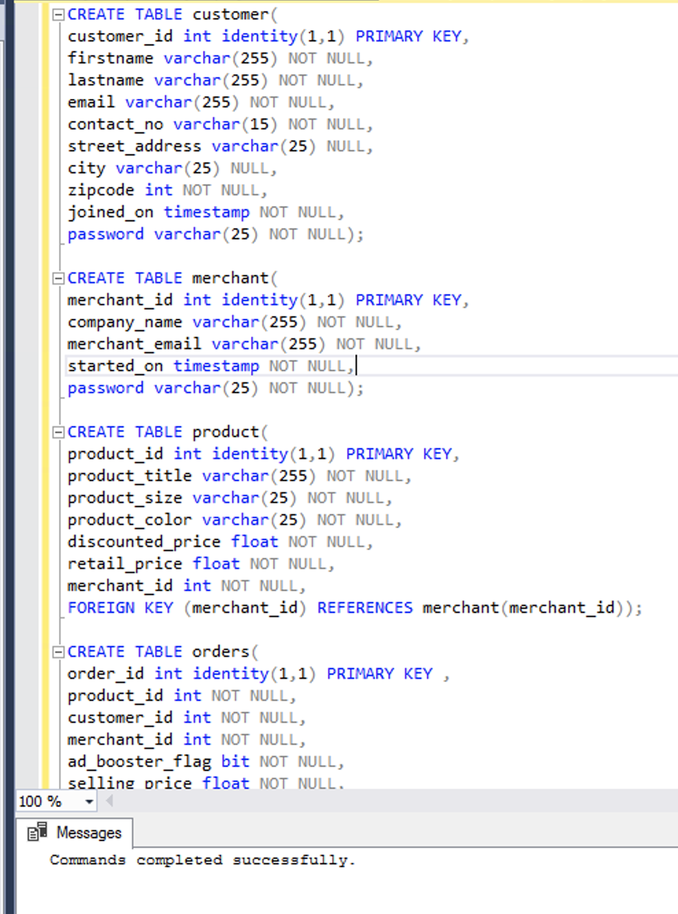

We also created an additional Security tables as below:

**Below table is only for Triggers that we will create in future**

CREATE TABLE [dbo].[SQLLogReport](

[id] [int] IDENTITY(1,1) NOT NULL,

[tableName] [varchar](100) NULL,

[description] [varchar](max) NULL,

[date_time] [datetime] NULL,

[InsertOrIpdate] [varchar](10) NULL,

PRIMARY KEY CLUSTERED

(

[id] ASC

)WITH (PAD_INDEX = OFF, STATISTICS_NORECOMPUTE = OFF, IGNORE_DUP_KEY = OFF, ALLOW_ROW_LOCKS = ON, ALLOW_PAGE_LOCKS = ON) ON [PRIMARY]

) ON [PRIMARY] TEXTIMAGE_ON [PRIMARY]

Security Tables:

CREATE TABLE [dbo].[sec_apps](

[app_name] [varchar](150) NOT NULL,

[app_type] [varchar](max) NULL,

[description] [varchar](max) NULL,

PRIMARY KEY CLUSTERED

( [app_name] ASC)

)

CREATE TABLE [dbo].[sec_groups](

[group_id] [int] IDENTITY(1,1) NOT NULL,

[description] [varchar](255) NULL,

PRIMARY KEY CLUSTERED

([group_id] ASC))

CREATE TABLE [dbo].[sec_groups_apps](

[group_id] [int] NOT NULL,

[app_name] [varchar](150) NOT NULL,

[priv_access] [varchar](max) NULL,

[priv_insert] [varchar](max) NULL,

[priv_delete] [varchar](max) NULL,

[priv_update] [varchar](max) NULL,

[priv_export] [varchar](max) NULL,

[priv_print] [varchar](max) NULL,

PRIMARY KEY CLUSTERED

([group_id] ASC,

[app_name] ASC))

CREATE TABLE [dbo].[sec_users](

[login] [varchar](150) NOT NULL,

[pswd] [varchar](150) NOT NULL,

[name] [varchar](max) NULL,

[email] [varchar](max) NULL,

[usr_active] [varchar](max) NULL,

[activation_code] [varchar](max) NULL,

[priv_admin] [varchar](max) NULL,

PRIMARY KEY CLUSTERED

([login] ASC))

CREATE TABLE [dbo].[sec_users_groups](

[login] [varchar](150) NOT NULL,

[group_id] [int] NOT NULL,

PRIMARY KEY CLUSTERED

([login] ASC,[group_id] ASC))

CREATE TABLE [dbo].[sc_log](

[id] [int] IDENTITY(1,1) NOT NULL,

[inserted_date] [datetime] NULL,

[username] [varchar](90) NOT NULL,

[application] [varchar](200) NOT NULL,

[creator] [varchar](30) NOT NULL,

[ip_user] [varchar](32) NOT NULL,

[action] [varchar](30) NOT NULL,

[description] [varchar](max) NULL,

PRIMARY KEY CLUSTERED

( [id] ASC))

## Data Upload & Conversion

Here are the sample of data that is loaded in each table:

**Table Customer:**

insert into customer values(189001,'Edwin','Seefus','eseefus0@wp.com',5108934678,'73116 Commercial Crossing','san jose',95186,'srghbsd','2021-03-03');

insert into customer values(189002,'Jesus','Stag','jstag1@ucoz.ru',8357893652,'59058 Dapin Drive','san jose',95186,'sfghd','2021-03-04');

insert into customer values(189003,'Danita','Kimbling','dkimbling2@accuweather.com',4927405861,'1683 Emmet Place','san jose',95186,'345gdfgh','2021-03-05');

insert into customer values(189004,'Jammie','Ragdale','jragdale3@cbc.ca',1947589304,'872 Drewry Place','santa clara',95186,'457fcgh5','2021-03-06');

insert into customer values(189005,'Kelsey','Kenset','kkenset4@addtoany.com',8204689023,'01942 Ilene Center','santa clara',95186,'drggfb7','2021-03-07');

insert into customer values(189006,'Georgette','Eller','geller5@google.cn',1685047856,'15 Pankratz Trail','santa clara',95186,'45645ghn','2021-03-08');

insert into customer values(189007,'Meghann','Shelp','mshelp6@bloglovin.com',9570936758,'48 Hanson Terrace','santa clara',95183,'ngyjh86','2021-03-09');

insert into customer values(189008,'Genevieve','Kirkbride','gkirkbride7@cornell.edu',8465012869,'962 Heath Crossing','milpitas',95183,'sdfv345','2021-03-10');

insert into customer values(189009,'Grover','Dugmore','gdugmore8@instagram.com',7492675967,'5025 Maple Wood Plaza','milpitas',95183,'hjmhgjmk9','2021-03-11');

insert into customer values(189010,'Joyann','Brandt','jbrandt9@redcross.org',7486974958,'2 Vernon Center','milpitas',95836,'sfgv456','2021-03-12');

insert into customer values(189011,'Trefor','Nutter','tnuttera@networkadvertising.org',3719467832,'43918 Stoughton Circle','milpitas',94852,'fhjnnky6','2021-03-13');

insert into customer values(189012,'Hieronymus','Vesty','hvestyb@goodreads.com',4950683618,'166 Westend Avenue','milpitas',89362,'aedfcgb4','2021-03-14');

**Table Merchant:**

insert into merchant values(202001,'Bechtelar, Jerde and Lowe','dshurmore0@paginegialle.it','lihklj34','2018-03-04');

insert into merchant values(202002,'Lind, West and Yost','mhelling1@howstuffworks.com','dfgyg7656','2018-03-05');

insert into merchant values(202003,'Grady, Hansen and Hyatt','jdassindale2@t-online.de','fghfgb75','2018-03-06');

insert into merchant values(202004,'Champlin, Kling and Jacobi','ktitheridge3@example.com','fgjfgb657','2019-03-07');

insert into merchant values(202005,'Rohan, Renner and Welch','nlayman5@wiley.com','dfhtukjmjc467','2018-03-05');

insert into merchant values(202006,'Schumm Inc','ljanssen6@google.ru','drgdf55','2019-03-09');

insert into merchant values(202007,'Altenwerth Inc','rboynes7@pcworld.com','dthrtwg23','2018-03-10');

insert into merchant values(202008,'Bahringer-Maggio','fgarrard8@histats.com','hugjmg657','2018-03-11');

insert into merchant values(202009,'Wiza-Predovic','grape9@geocities.com','acrgh4','2020-03-12');

insert into merchant values(202010,'Johnston and Sons','mdoaga@archive.org','hghbdg965','2018-03-13');

insert into merchant values(202011,'Dooley, Thompson and Brekke','lmullearyb@ed.gov','356ggb','2016-06-07');

insert into merchant values(202012,'Quigley-Armstrong','alahyc@geocities.jp','gk6h','2016-06-08');

insert into merchant values(202013,'Raynor-Rempel','gtruscottd@ucoz.com','drgdf55','2016-06-09');

insert into merchant values(202014,'Abshire-White','fbthame@networksolutions.com','r6tfdgtu6','2016-06-10);

insert into merchant values(202015,'Larson, Wolf and Hoppe','lwarwickerf@ihg.com','ert3','2016-06-11');

insert into merchant values(202016,'Grimes, Ferry and Fahey','mtanzigg@disqus.com','ethj654','2016-06-12');

insert into merchant values(202017,'Waters, Vandervort and Reinger','lquoganh@state.gov','bjhnjgf77','2016-06-13');

insert into merchant values(202018,'Zulauf-Bauch','browstoni@google.pl','dtgtrghhjj','2016-06-14');

insert into merchant values(202019,'Kiehn-Mertz','jallsopj@usatoday.com','edwdgy','2016-06-15');

**Table Product:**

insert into product values ('130001','2020 Summer Vintage Flamingo Print ','M','white',16,14,202001);

insert into product values ('130002','SSHOUSE Summer Casual Sleeveless ','XS','green',8,22,202002);

insert into product values ('130003','2020 Nouvelle','XS','leopardprint',8,43,202003);

insert into product values ('130004','Plus la taille','null','navyblue',3.92,9,202004);

insert into product values ('130005','Women Fashion Loose ','XS','white',7,6,202005);

insert into product values ('130006','Robe tunique ','M.','blue',12,11,202006);

insert into product values ('130007','Robe ','M','black',11,84,202007);

insert into product values ('130008',' floral Blouse Tops','S','beige',5.78,22,202008);

insert into product values ('130009','Femmes Mode ','XXS','NIL',5.79,5,202009);

insert into product values ('130010','Shorts','XS','orange',1.91,6,202010);

**Table order:**

insert into orders values(15060001,130001,189002,202001,1,16,'2020-05-02','2020-05-06');

insert into orders values(15060002,130002,189003,202002,0,8,'2020-05-01','2020-05-05');

insert into orders values(15060003,130003,189004,202003,1,8,'2020-05-25','2020-05-29');

insert into orders values(15060004,130004,189005,202004,1,3.92,'2020-05-23','2020-05-27');

insert into orders values(15060005,130005,189006,202005,1,7,'2020-05-22','2020-05-28');

insert into orders values(15060006,130006,189007,202006,0,12,'2020-05-08','2020-05-11');

insert into orders values(15060007,130007,189008,202007,1,11,'2020-05-19','2020-05-22');

insert into orders values(15060008,130008,189009,202008,1,5.78,'2020-05-12','2020-05-15');

**Table Shipping:**

insert into shipping values(20200801,15060001,1,5.34,'2020-03-05');

insert into shipping values(20200802,15060002,2,3,'2020-03-05');

insert into shipping values(20200803,15060003,3,5.4,'2020-03-05');

insert into shipping values(20200804,15060004,1,1.1,'2020-03-05');

insert into shipping values(20200805,15060005,2,1,'2020-03-19');

insert into shipping values(20200806,15060006,3,3.6,'2020-03-20');

insert into shipping values(20200807,15060007,1,7,'2020-03-21');

insert into shipping values(20200808,15060008,3,2,'2020-03-22');

insert into shipping values(20200809,15060009,2,5.1,'2020-03-23');

insert into shipping values(20200810,15060010,1,6,'2020-03-24');

insert into shipping values(20200811,15060011,1,2,'2020-03-25');

insert into shipping values(20200812,15060012,1,2,'2020-03-26');

insert into shipping values(20200813,15060013,2,5,'2020-03-27');

**Table merchant_rating:**

insert into merchant_rating values(202001,189001,4.26,'good','2020-05-05');

insert into merchant_rating values(202002,189002,4.014,'fair','2020-05-06');

insert into merchant_rating values(202003,189003,4.337,'perfect shape','2020-05-09');

insert into merchant_rating values(202004,189004,3.949,'good','2020-05-08');

insert into merchant_rating values(202005,189005,4.261,'fair','2020-05-09');

insert into merchant_rating values(202006,189006,4.015,'perfect shape','2020-05-10');

insert into merchant_rating values(202007,189007,4.341,'nice','2020-05-11');

insert into merchant_rating values(202008,189008,4.249,'good','2020-05-03');

insert into merchant_rating values(202009,189009,4.264,'fair','2020-05-10');

insert into merchant_rating values(202010,189010,3.646,'perfect shape','2020-05-14');

insert into merchant_rating values(202011,189011,4.019,'good','2020-05-15');

insert into merchant_rating values(202012,189012,4.343,'fair','2020-05-16');

insert into merchant_rating values(202013,189013,3.991,'perfect shape','2020-05-11');

**Table Badges:**

insert into badges values(5431,'x1','local_product','2020-01-07');

insert into badges values(5432,'x2','local_product','2020-01-04');

insert into badges values(5433,'x3','fast shiping','2020-01-05');

insert into badges values(5434,'x4','qiality','2020-01-01');

insert into badges values(5435,'x5','local_product','2020-01-01');

insert into badges values(5436,'x6','local_product','2021-01-08');

**Table product_rating:**

insert into product_ratings values(1,189001,130001,3.76,'nice','2020-12-05');

insert into product_ratings values(2,189002,130002,3.45,'fair','2020-12-06');

insert into product_ratings values(3,189003,130003,3.57,'good','2020-12-07');

insert into product_ratings values(4,189004,130004,5,'loved it','2020-12-08');

insert into product_ratings values(5,189005,130005,3.84,'okay','2020-12-09');

insert into product_ratings values(6,189006,130006,3.76,'nice','2020-12-10');

insert into product_ratings values(7,189007,130007,3.47,'fair','2020-12-11');

insert into product_ratings values(8,189008,130008,3.6,'good','2020-12-12');

insert into product_ratings values(9,189009,130009,3.46,'loved it','2020-12-13');

insert into product_ratings values(10,189010,130010,3.45,'okay','2020-12-14');

insert into product_ratings values(11,189011,130011,3.65,'okay','2020-12-15');

**Table product_badges:**

insert into product_badges values(5431,130001,'2020-01-03');

insert into product_badges values(5432,130002,'2028-01-04');

insert into product_badges values(5433,130003,'2020-01-05');

insert into product_badges values(5434,130004,'2020-01-09');

insert into product_badges values(5435,130005,'2020-01-01');

insert into product_badges values(5436,130006,'2029-01-08');

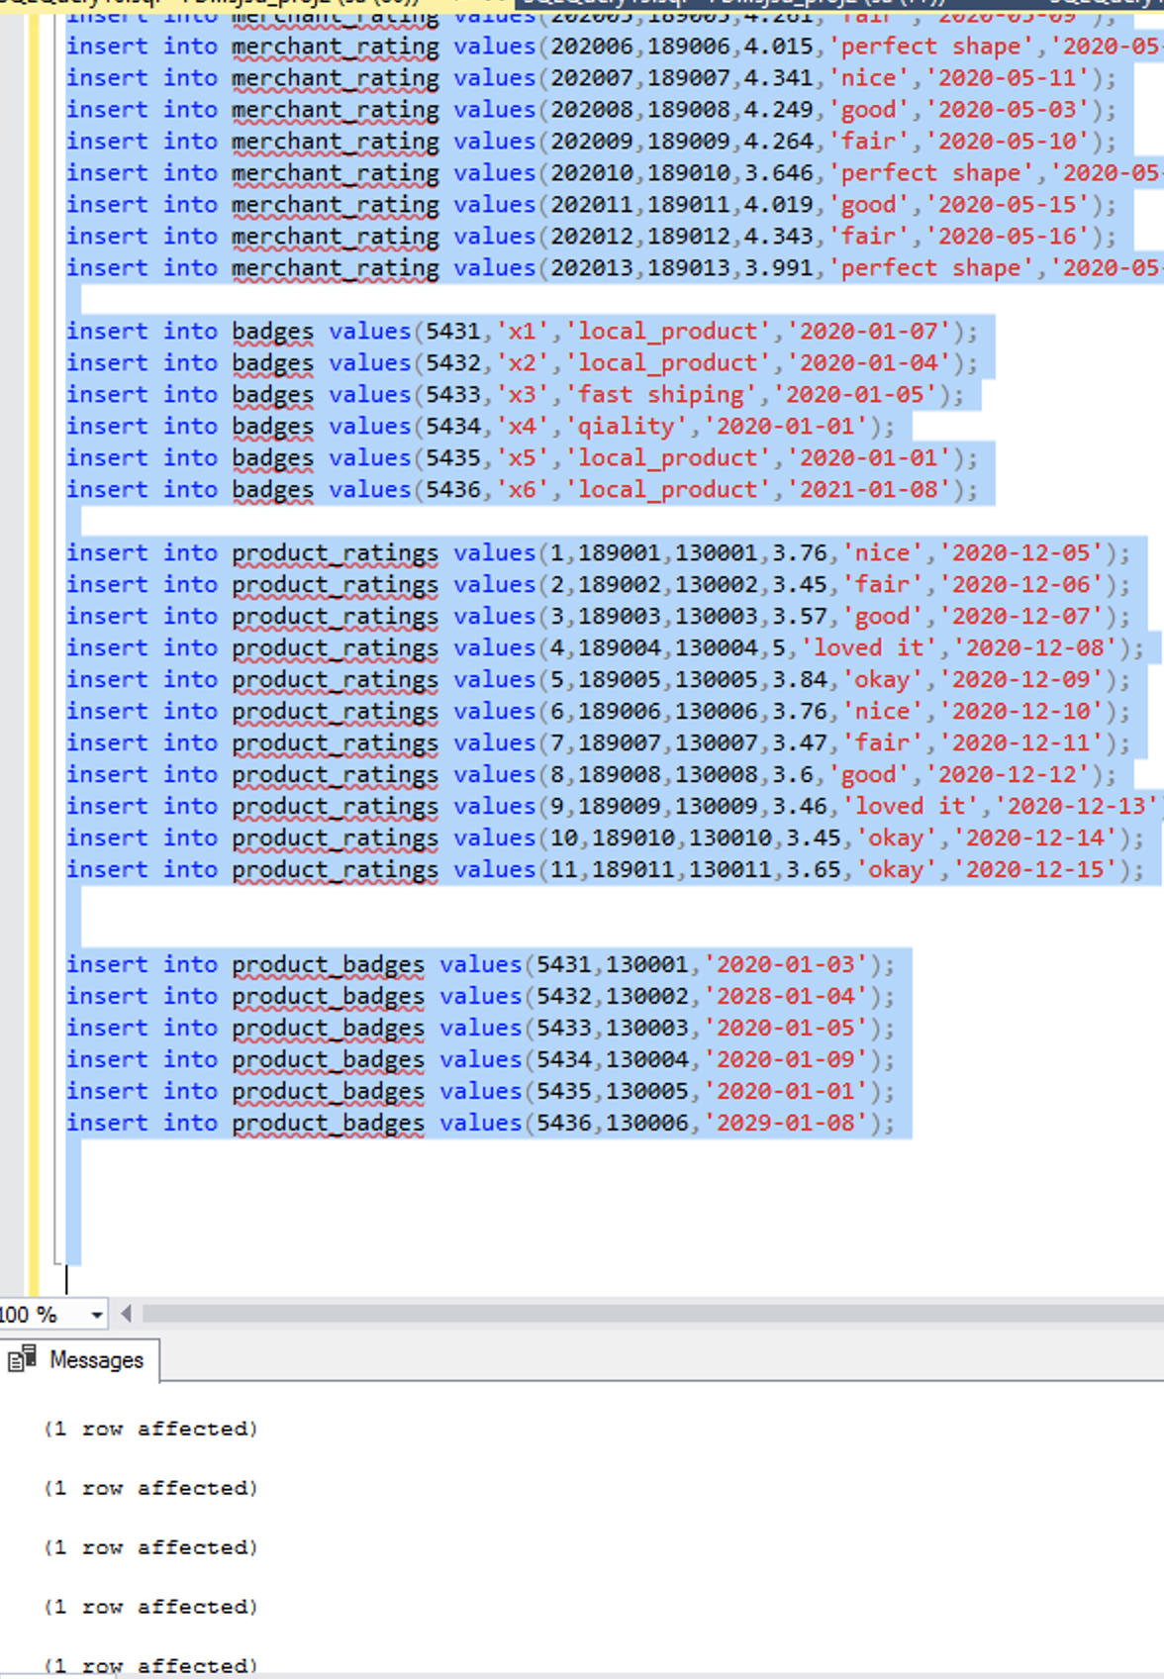

# Testing & Evaluation:

Testing is one of the first ways to reassure that our database model design is a healthy one and is functioning in the way we wanted it to be.

The logical design involves first the selection of entities and attributes. But when it comes to Load the data in MSSQL Server 2016 we first create the table and insert the data according to our entities and attributes.

Due to the nature of the project, it is better to assure that our database created complies with Primary key and foreign key constraints. After creation of all the necessary tables, we insert the data into each table using the Insert statement.

We purposely tried to insert a few rows in the query that does not match the foreign key constraint in the parent table. Below screenshot shows that the Referential integrity is followed

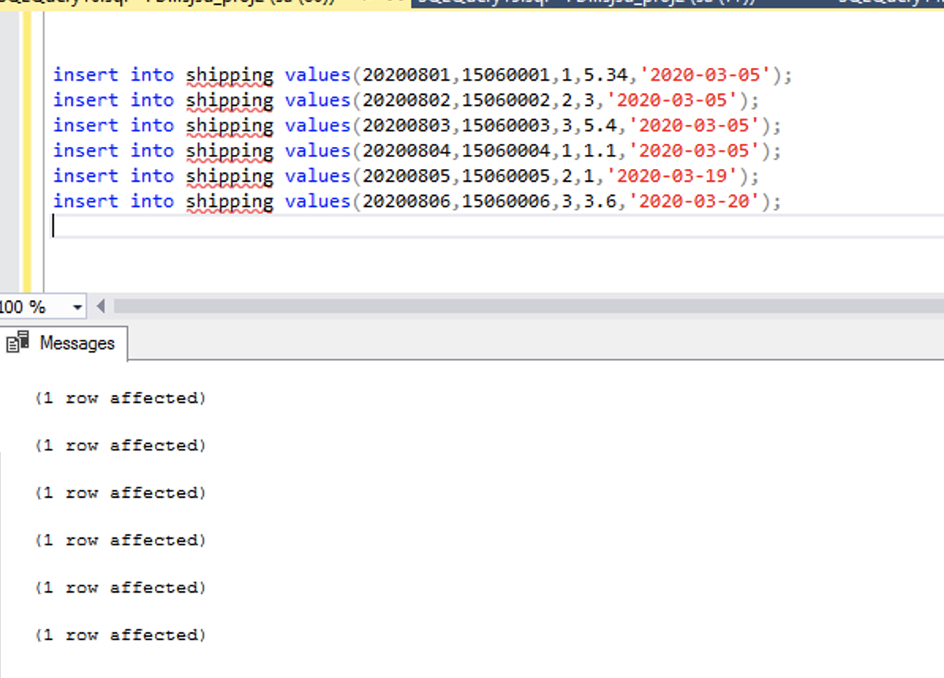

The following screenshot is an example showing that we are trying to add child data before adding the parent data. And we got the following error:

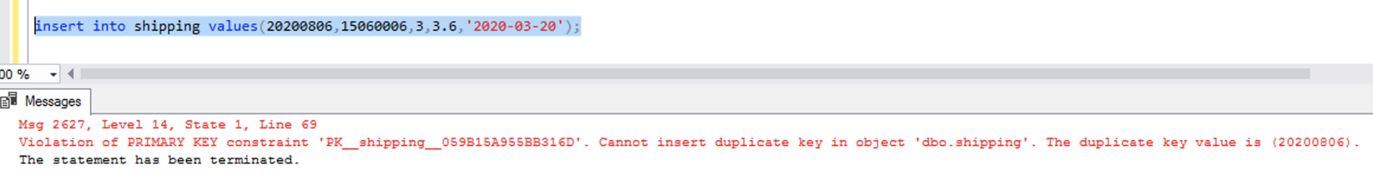

This proves that only the data that had primary and foreign key relationship is inserted in the database hence assuring relationship integrity.

Performing join operation over the data across the tables is another method we have implemented to perform testing operation.

select top 7

c.firstname,c.lastname,p.product_title,product_size,o.selling_price

from orders o

join product p on o.product_id=p.product_id

join customer c on c.customer_id=o.customer_id

order by order_id ;

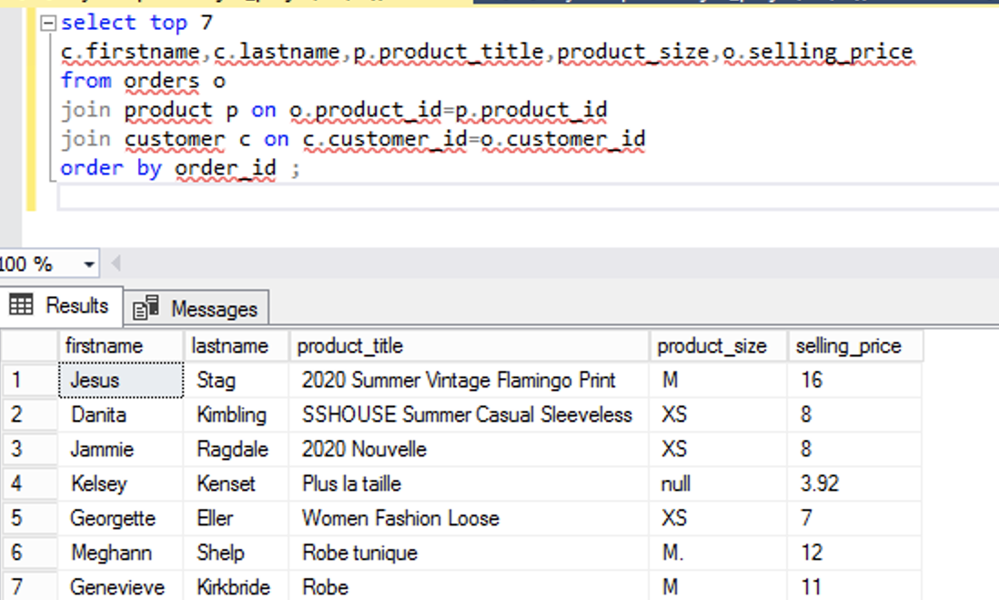

select top 5

p.product_id,p.product_title,p.product_size,p.discounted_price,p.retail_price,r.rating_value,

r.comment,b.badge_name,b.badge_type,b.created_on

from product p

join product_ratings r on r.product_id=p.product_id

join product_badges pb on pb.product_id=p.product_id

join badges b on b.badge_id=pb.badge_id

order by product_id;

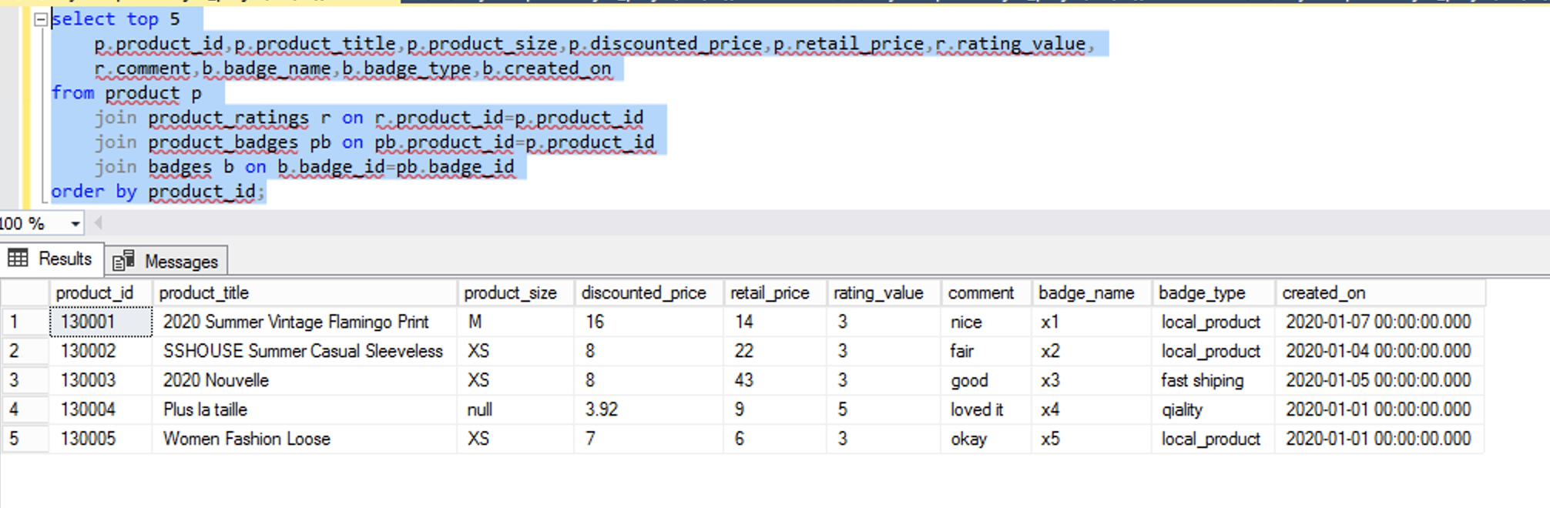

## Query Description:

**Scenario 1:**

If a merchant uses either shipping ”Tier-1” or “Tier 2” method to ship the product to the customer. They are eligible for the **“All-star shipper badge”.**

To find the list of products and its associate merchants who are eligible for the badge:

**Solution:**

select distinct top 5 o.product_id,s.shipping_tier,o.merchant_id

from shipping s

join orders o on o.order_id=s.order_id

where s.shipping_tier in (1,2);

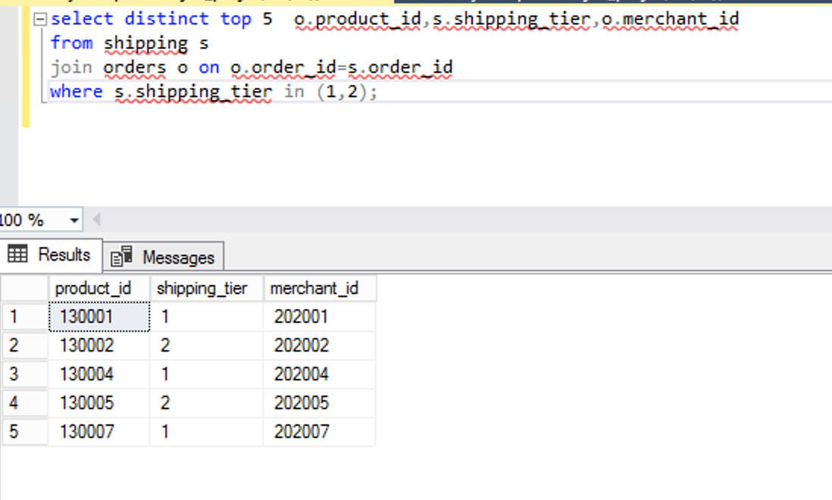

**Scenario 2:**

Lack of product description will reduce the visibility of the product.

Selecting the product that is missing the product size and product color, in order to remind the respective merchants.

**Solution:**

select p.product_title,p.product_id,m.merchant_id

from product p

inner join merchant m on p.merchant_id=m.merchant_id

where p.product_size is null or p.product_color is null;

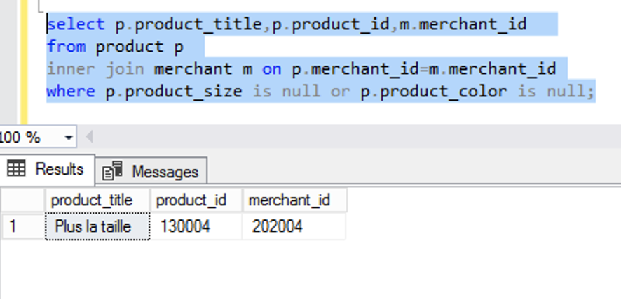

In our current database we do have only one null value. But as the data is added every day, this query checks for null values and sends reminders to the customer.

**Scenario 3:**

If a merchant does not initiate the fulfillment process within 3 days of the order placed date. The merchant will be flagged and might be subjected to penalty.

Selecting the merchant who has passed 3 day of fulfillment date:

**Solution:**

select top 5

p.product_id,p.product_title,p.product_size,p.discounted_price,p.retail_price,r.rating_value,

r.comment,b.badge_name,b.badge_type,b.created_on

from product p

join product_ratings r on r.product_id=p.product_id

join product_badges pb on pb.product_id=p.product_id

join badges b on b.badge_id=pb.badge_id

order by product_id;



**Scenario 4:**

We want to find out how many ratings we have in some specific cities such as San jose, santa clara and Milpitas but also want to know about the reviews which come from customers and also know what the product name is. In this query we can find out the related info and also contact the reviewers if needed.

**Solution:**

select concat(firstname,' ',lastname) as fullName, email,contact_no as ContactNumber, city, pr.rating_value,pr.comment,p.product_title,

count(*) over (partition by city) as ratingsCountBasedOnCities

from customer c

inner join product_ratings pr on pr.customer_id=c.customer_id

inner join product p on p.product_id=pr.product_id

where city in('San Jose','Santa Clara','Milpitas')

group by city,firstname,lastname,email,contact_no,pr.rating_value,pr.comment,p.product_title

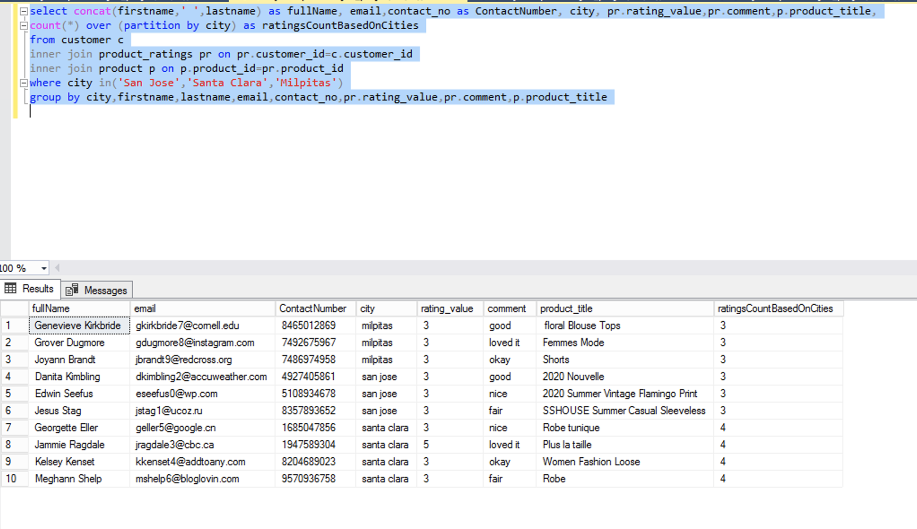

**Senario 5:**

This will show all customer info with row numbers based on each city. This will show us an overview of the city sequence.

**Solution:**

select *,

ROW_NUMBER() over (partition by city order by lastname) as RowNumberBasedOnCity

from customer

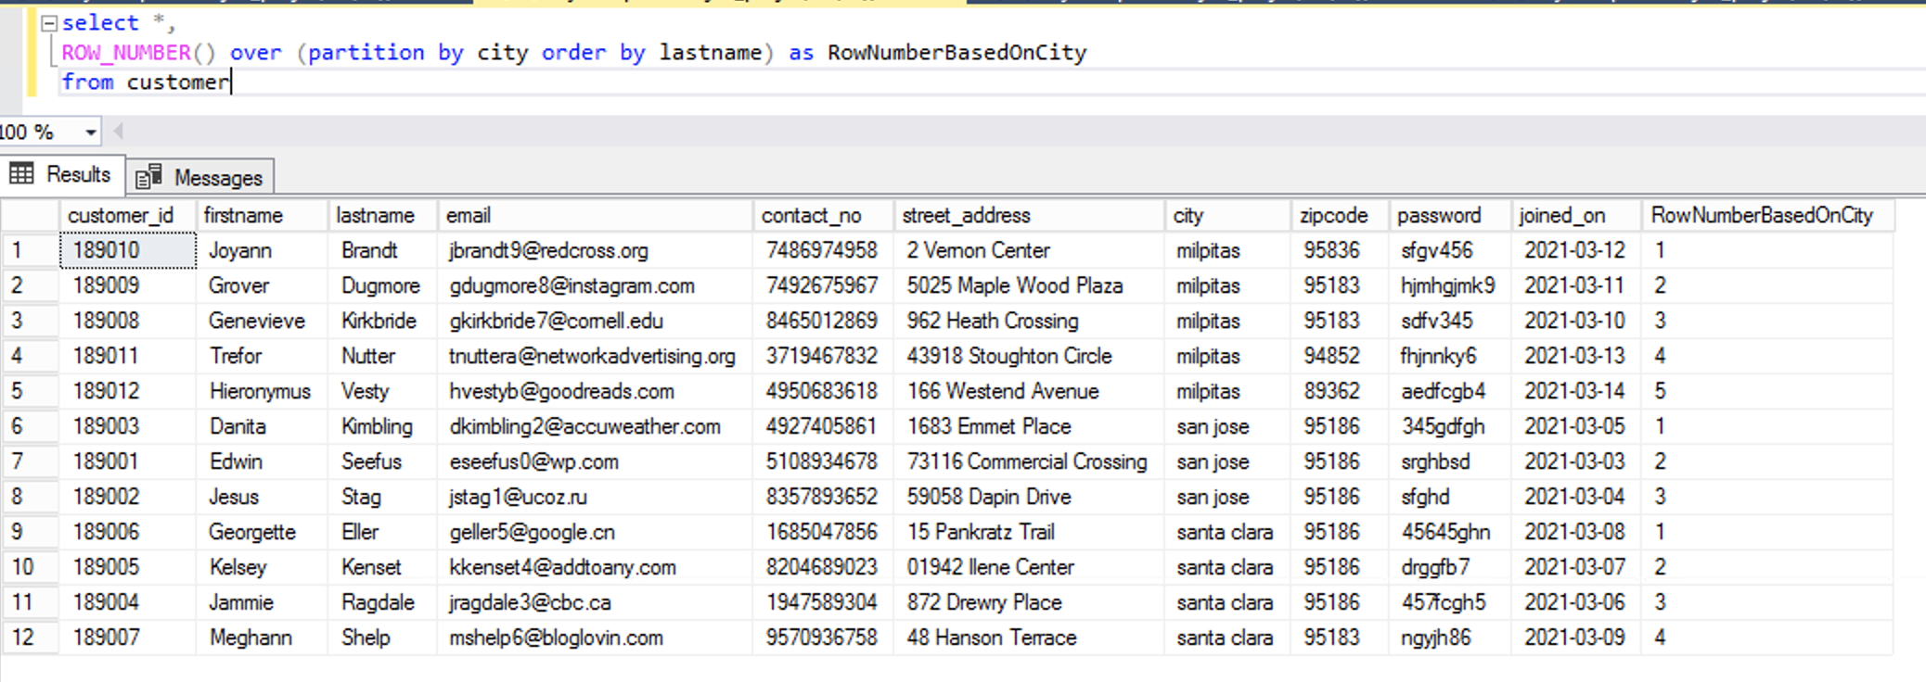

**Senario 6:**

This query will find the product information with the merchant email and title and when they have their badges awarded. We find only a specific date here.

**Solution:**

select p.*,m.company_name,m.merchant_email,cast(pb.awared_on as date) as awared_on,b.badge_type

from product p

inner join product_badges pb on pb.product_id=p.product_id

inner join Badges b on b.badge_id=pb.badge_id

inner join merchant m on m.merchant_id=p.merchant_id

where awared_on between '2020-01-01' and '2021-02-01'

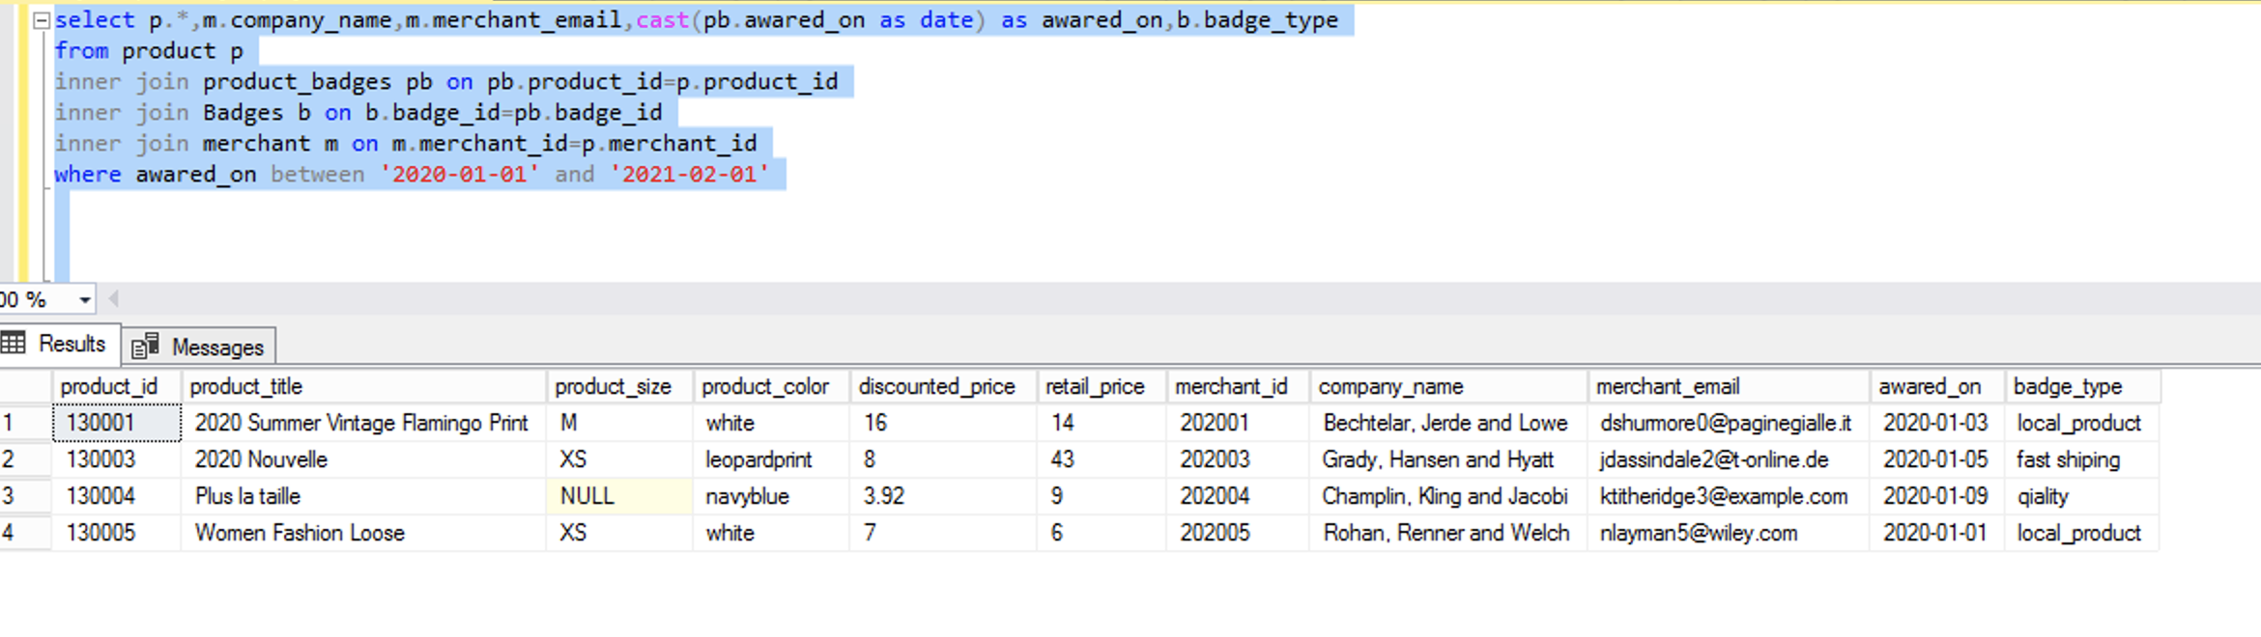

**Scenario 7:**

We want to find the running sum of the selling price based on the week of the order_date. Below we created the query for weeks between 18 to 22

**Solution:**

select *,DATEPART(WEEK,order_date),

sum(selling_price) over (partition by DATEPART(WEEK,order_date))

from orders

where DATEPART(WEEK,order_date)<23 and DATEPART(WEEK,order_date)>17

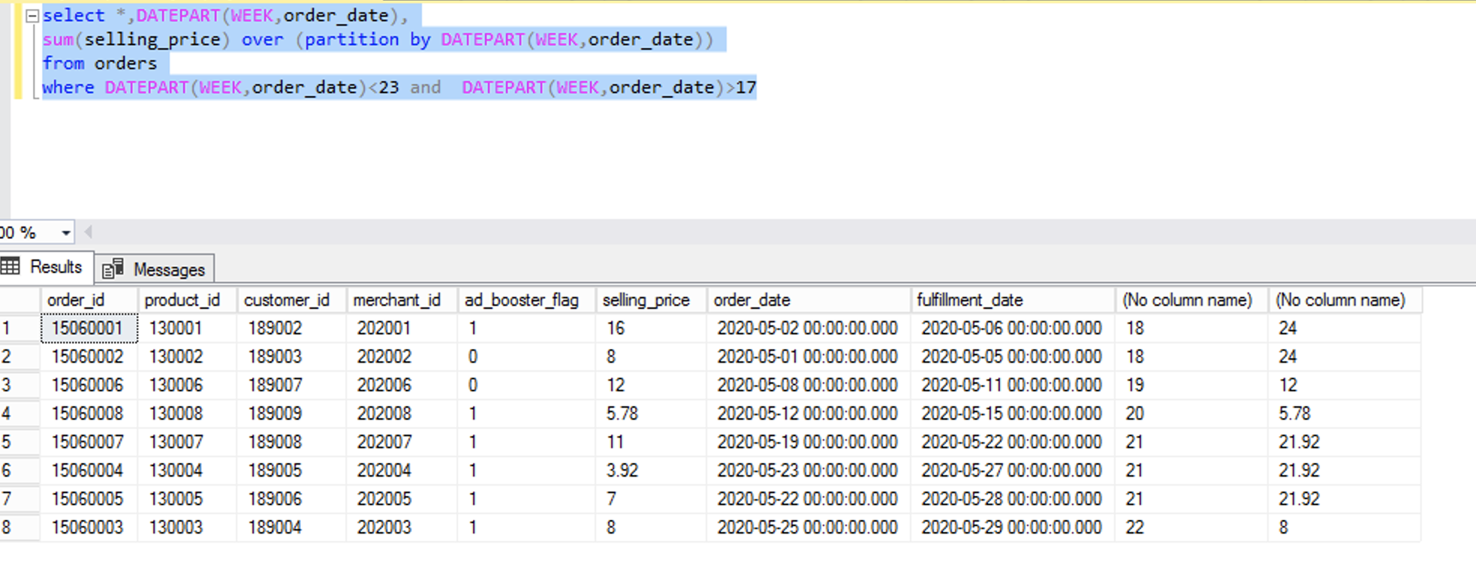

**Scenario 8:**

Here is to show all shipping info along with the customer info and merchant name that has cheap shipping rate. We can specify any number, even free shipping so customers can look only for free or any specific price. (Will implement this on UI)

**Solution:**

select o.order_id,shipping_tier,shipping_cost,cast(shipping_on as date),p.product_title,concat(c.lastname,'. ',c.firstname) as Name,m.company_name from shipping s

inner join orders o on s.order_id=o.order_id

inner join product p on p.product_id=o.product_id

inner join customer c on c.customer_id=o.customer_id

inner join merchant m on m.merchant_id=o.merchant_id

where shipping_cost<=2

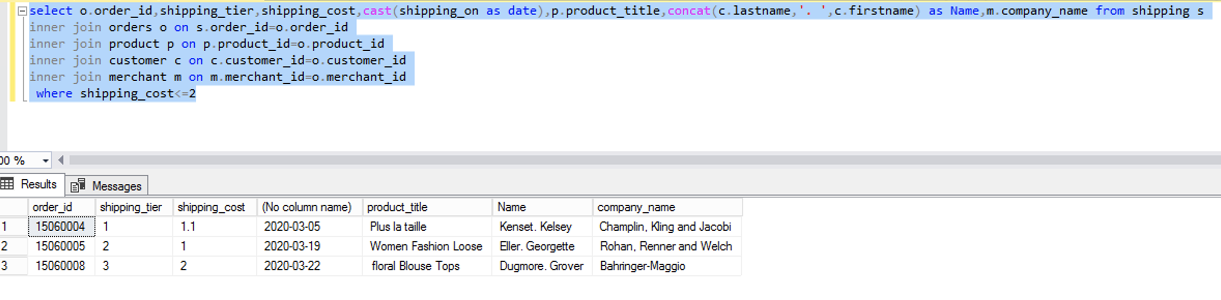

**Triggers:**

Below triggers help us to have SQL Log reports for Badge and Customer tables so whenever there is a delete or New data in Badge and Customer tables, it will record it in SQLLogReport table.

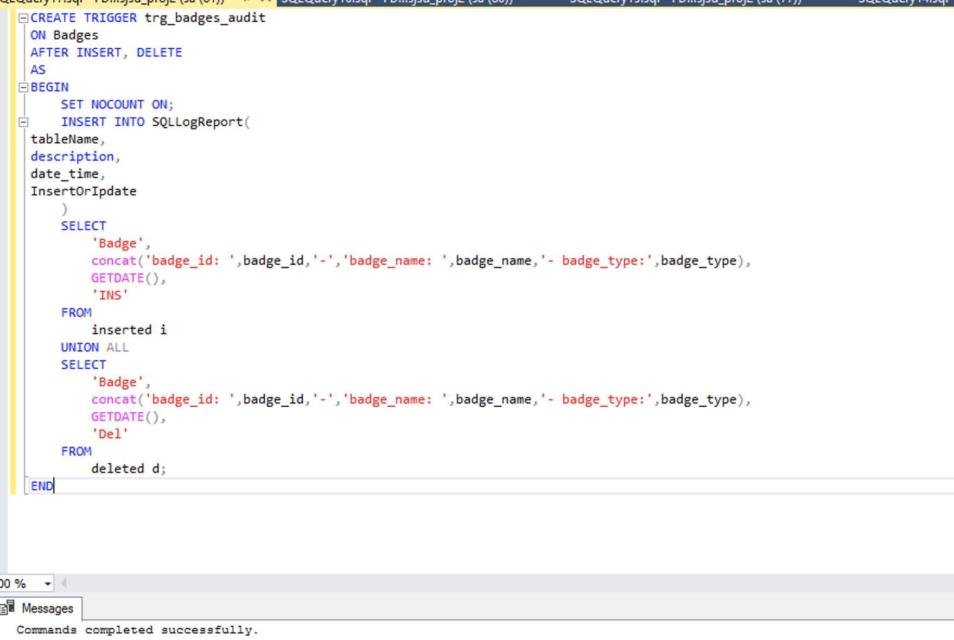

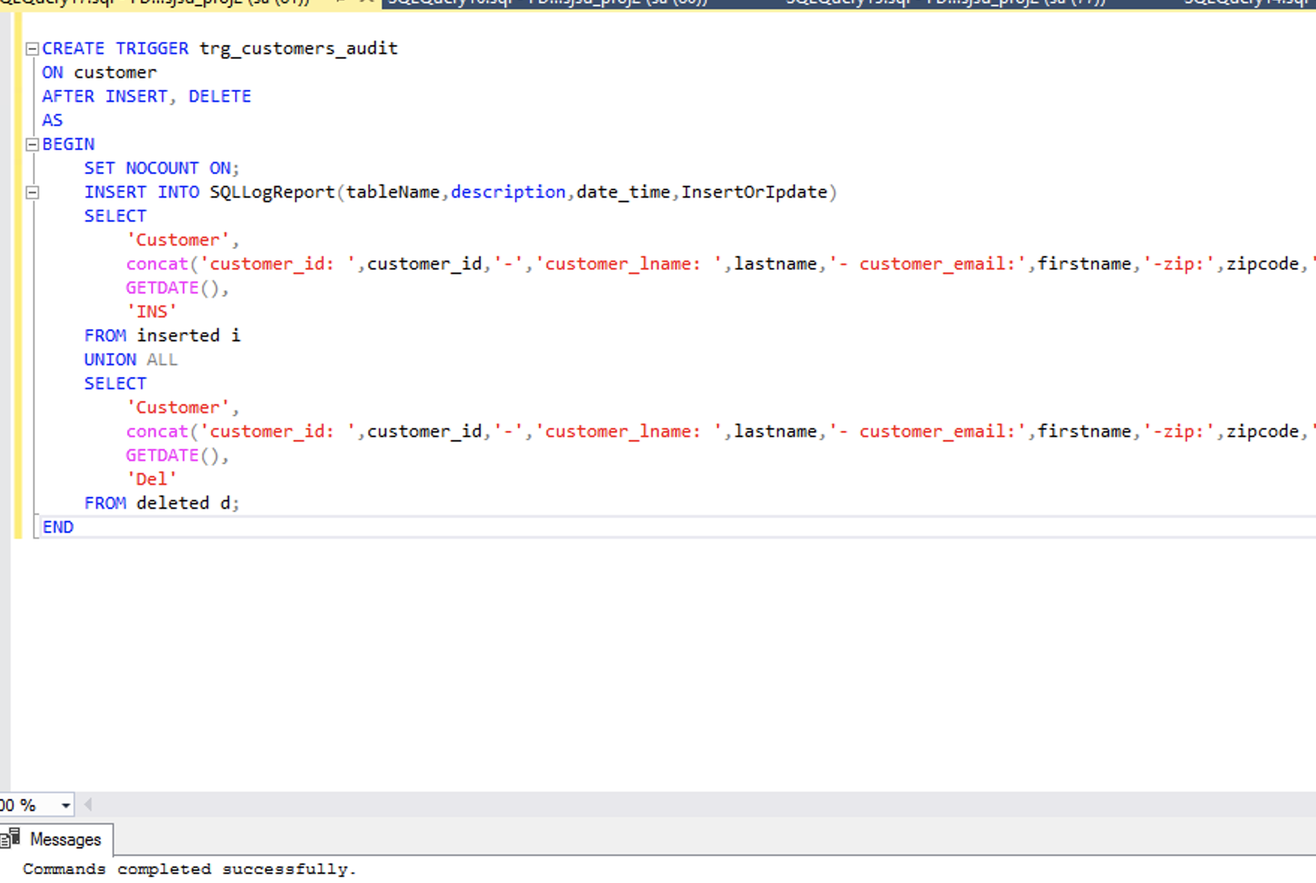

# Summary and conclusion:

Each ecommerce business uses a different strategy to survive in this competitive market. Thus, we create a successful business model that can be used by an ecommerce application which sells products from small to large scale.

The ways that a business can outstand its competition is by making sure the products are legit and promises to deliver what is described. This can be checked frequently in order to maintain the business integrity.

Customer’s feedback should be constantly monitored to keep the products and their merchants in check. As a feedback towards a product is a feedback toward the business itself. By introducing innovative product promotion campaigns like coupons and add boosters

We can bring in more frequent buyers and new shoppers.